**Assignment - 16 A Job Ready Bootcamp in C++, DSA and IOT**

Multi-Dimensional Array in C Language

**1. Write a program to calculate the sum of two matrices each of order 3x3.**

#include<stdio.h>

int main()

{

int a[3][3],b[3][3],c[3][3],i,j;

printf("Enter data in 1st Matrix\n");

for(i=0;i<3;i++)

{

for(j=0;j<3;j++)

scanf("%d",&a[i][j]);

}

printf("Enter data in 2nd Matrix\n");

for(i=0;i<3;i++)

{

for(j=0;j<3;j++)

scanf("%d",&b[i][j]);

}

for(i=0;i<3;i++)

{

for(j=0;j<3;j++)

{

c[i][j]=0;

c[i][j]= a[i][j] + b[i][j];

}

}

printf("\n.....Sum of Two matrix is.....\n");

for(i=0;i<3;i++)

{

for(j=0;j<3;j++)

{

printf("%d ",c[i][j]);

}

printf("\n");

}

return 0;

}

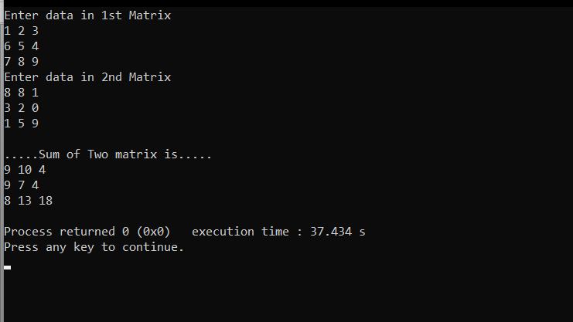

**2. Write a program to calculate the product of two matrices each of order 3x3.**

#include<stdio.h>

int main()

{

int a[3][3],b[3][3],c[3][3],i,j,k;

printf("Enter data in 1st Matrix\n");

for(i=0;i<3;i++)

{

for(j=0;j<3;j++)

scanf("%d",&a[i][j]);

}

printf("Enter data in 2nd Matrix\n");

for(i=0;i<3;i++)

{

for(j=0;j<3;j++)

scanf("%d",&b[i][j]);

}

for(i=0;i<3;i++)

{

for(j=0;j<3;j++)

{

c[i][j]=0;

for(k=0;k<3;k++)

{

c[i][j]+= a[i][k] * b[k][j];

}

}

}

printf("\n.....Product of Two matrix is.....\n\n");

for(i=0;i<3;i++)

{

for(j=0;j<3;j++)

{

printf("%d ",c[i][j]);

}

printf("\n");

}

return 0;

}

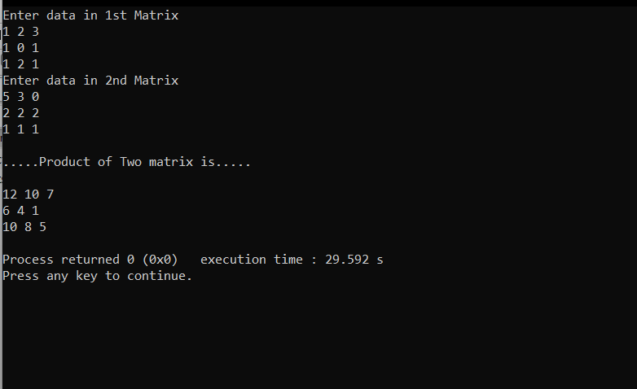

**3. Write a program in C to find the transpose of a given matrix.**

#include<stdio.h>

int main()

{

int a[10][10],c[10][10],row,col,i,j;

printf("Enter Row And Column of a matrix\n");

scanf("%d %d",&row,&col);

printf("Enter the data in the matrix\n");

for(i=0;i<row;i++)

{

for(j=0;j<col;j++)

{

scanf("%d",&a[i][j]);

}

}

for(i=0;i<col;i++)

{

for(j=0;j<row;j++)

{

c[i][j]=0;

c[i][j]=a[j][i];

}

}

printf("...Transpose of the Matrix is......\n");

for(i=0;i<col;i++)

{

for(j=0;j<row;j++)

{

printf("%d ",c[i][j]);

}

printf("\n");

}

return 0;

}

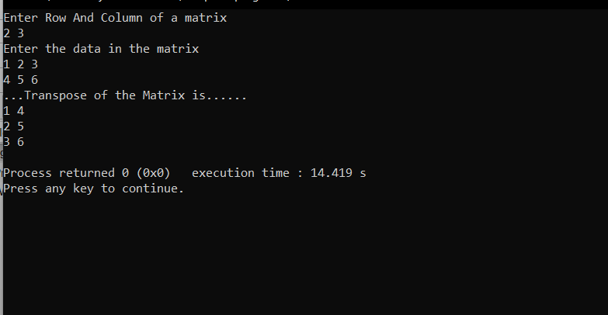

**4. Write a program in C to find the sum of right diagonals of a matrix.**

#include<stdio.h>

int main()

{

int a[10][10],c[10][10],row,col,i,j,sum=0;

printf("Enter Row And Column of a matrix\n");

scanf("%d %d",&row,&col);

printf("Enter the data in the matrix\n");

for(i=0;i<row;i++)

{

for(j=0;j<col;j++)

{

scanf("%d",&a[i][j]);

}

}

for(i=0;i<row;i++)

{

for(j=0;j<col;j++)

{

if(j==col-1-i)

sum+=a[i][j];

}

}

printf("Sum of its Right diagonal is %d",sum);

return 0;

}

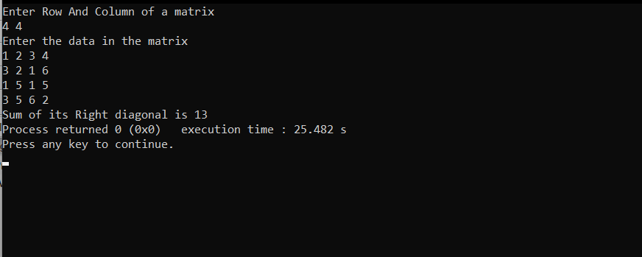

**5. Write a program in C to find the sum of left diagonals of a matrix**.

#include<stdio.h>

int main()

{

int a[10][10],row,col,i,j,sum=0;

printf("Enter Row And Column of a matrix\n");

scanf("%d %d",&row,&col);

printf("Enter the data in the matrix\n");

for(i=0;i<row;i++)

{

for(j=0;j<col;j++)

{

scanf("%d",&a[i][j]);

}

}

for(i=0;i<row;i++)

{

for(j=0;j<col;j++)

{

if(i==j)

sum+=a[i][j];

}

}

printf("Sum of its Left diagonal is %d",sum);

return 0;

}

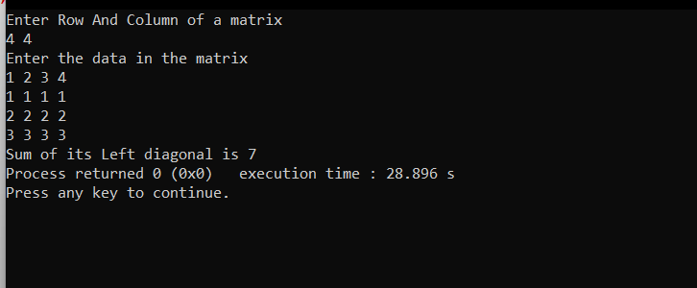

**6. Write a program in C to find the sum of rows and columns of a Matrix.**

#include<stdio.h>

int main()

{

int a[10][10],row,col,i,j,sumofrow=0,sumofcol=0;

printf("Enter Row And Column of a matrix\n");

scanf("%d %d",&row,&col);

printf("Enter the data in the matrix\n");

for(i=0;i<row;i++)

{

for(j=0;j<col;j++)

{

scanf("%d",&a[i][j]);

}

}

for(i=0;i<row;i++)

{

sumofrow=0;

for(j=0;j<col;j++)

{

sumofrow+=a[i][j];

}

printf("Sum of %d Row of Given Matrix is %d\n",i,sumofrow);

}

printf("\n\n");

for(i=0;i<col;i++)

{

sumofcol=0;

for(j=0;j<row;j++)

{

sumofcol+=a[j][i];

}

printf("Sum of %d Column of Given Matrix is %d\n",i,sumofcol);

}

return 0;

}

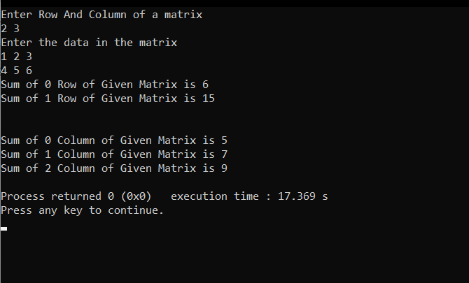

**7. Write a program in C to print or display the lower triangular of a given matrix.**

#include<stdio.h>

int main()

{

int a[10][10],row,col,i,j;

printf("Enter Row And Column of a matrix\n");

scanf("%d %d",&row,&col);

printf("Enter the data in the matrix\n");

for(i=0;i<row;i++)

{

for(j=0;j<col;j++)

{

scanf("%d",&a[i][j]);

}

}

printf("\nLower Triangular matrix\n");

for(i=0;i<row;i++)

{

for(j=0;j<col;j++)

{

if(j<=i)

printf("%d ",a[i][j]);

else

printf("0 ");

}

printf("\n");

}

return 0;

}

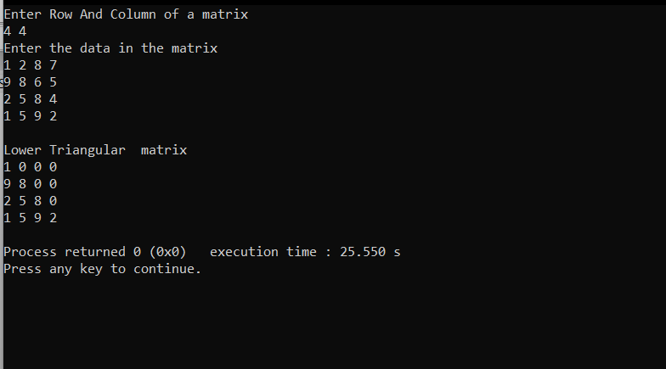

**8. Write a program in C to print or display an upper triangular matrix.**

#include<stdio.h>

int main()

{

int a[10][10],row,col,i,j;

printf("Enter Row And Column of a matrix\n");

scanf("%d %d",&row,&col);

printf("Enter the data in the matrix\n");

for(i=0;i<row;i++)

{

for(j=0;j<col;j++)

{

scanf("%d",&a[i][j]);

}

}

printf("\nUpper Triangular matrix\n");

for(i=0;i<row;i++)

{

for(j=0;j<col;j++)

{

if(j>=i)

printf("%d ",a[i][j]);

else

printf("0 ");

}

printf("\n");

}

return 0;

}

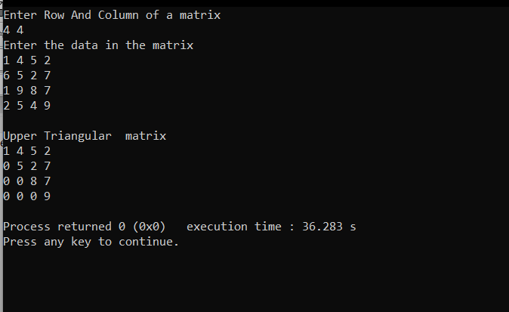

**9. Write a program in C to accept a matrix and determine whether it is a sparse matrix.**

#include<stdio.h>

int main()

{

int a[10][10],row,col,i,j,count=0;

printf("Enter Row And Column of a matrix\n");

scanf("%d %d",&row,&col);

printf("Enter the data in the matrix\n");

for(i=0;i<row;i++)

{

for(j=0;j<col;j++)

{

scanf("%d",&a[i][j]);

}

}

for(i=0;i<row;i++)

{

for(j=0;j<col;j++)

{

if(a[i][j]!=0)

count++;

}

}

if( count < ((row*col)/2) )

printf("Sparse Matrix");

else

printf("Not Sparse Matrix");

return 0;

}

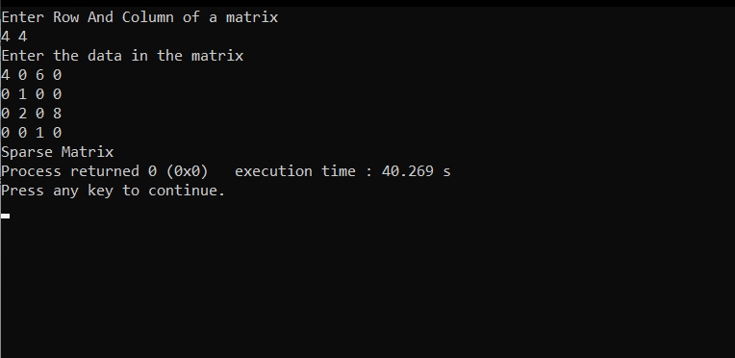

**10. Write a program in C to find the row with maximum number of 1s.**

#include<stdio.h>

int main()

{

int a[10][10],row,col,i,j,sum=0,max=0,index=0;

printf("Enter Row And Column of a matrix\n");

scanf("%d %d",&row,&col);

printf("Enter the data in the matrix\n");

for(i=0;i<row;i++)

{

for(j=0;j<col;j++)

{

scanf("%d",&a[i][j]);

}

}

for(i=0;i<row;i++)

{

sum=0;

for(j=0;j<col;j++)

{

if(a[i][j]==1)

sum+=a[i][j];

if(sum>max)

{

max=sum;

index=i;

}

}

}

printf("The row with maximum 1s is %d",index);

return 0;

}

